ENET Conference was held virtually again this year from 25 – 27 February 2021.
The opening Plenary session was presented by Wolf H Fridman (Cordeliers Research Centre, Paris, France) “Immunotherapy in Cancer”. The ultimate goal of immunotherapy is to modify the tumour microenvironment in primary and / or metastatic sites so as to increase the ratio of tumour specific memory T cells, predominantly CD8 effector cells, over suppressive inflammatory cells, and their mediator. It is also the goal to induce or increase a systemic antitumour response to residual malignant cancer cell. Where there are higher mutations there is higher efficacy. See the slide below which demonstrates the effect on Merkel Cell Carcinomas. There is still much work to be done in the NETs arena.
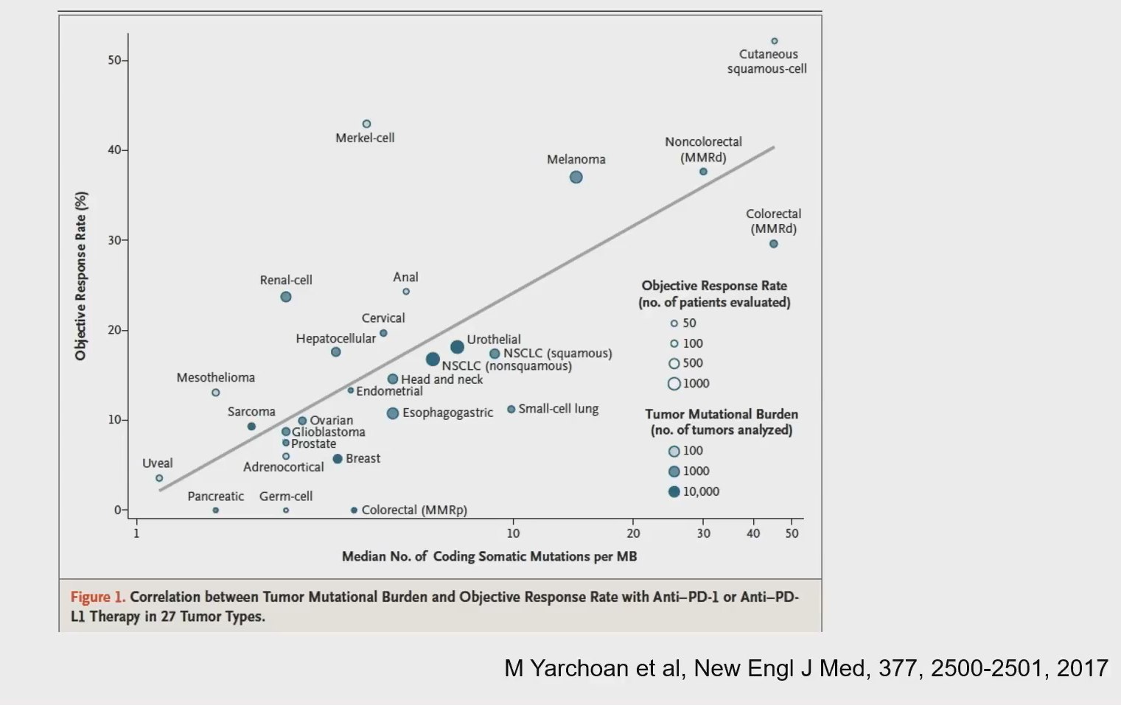

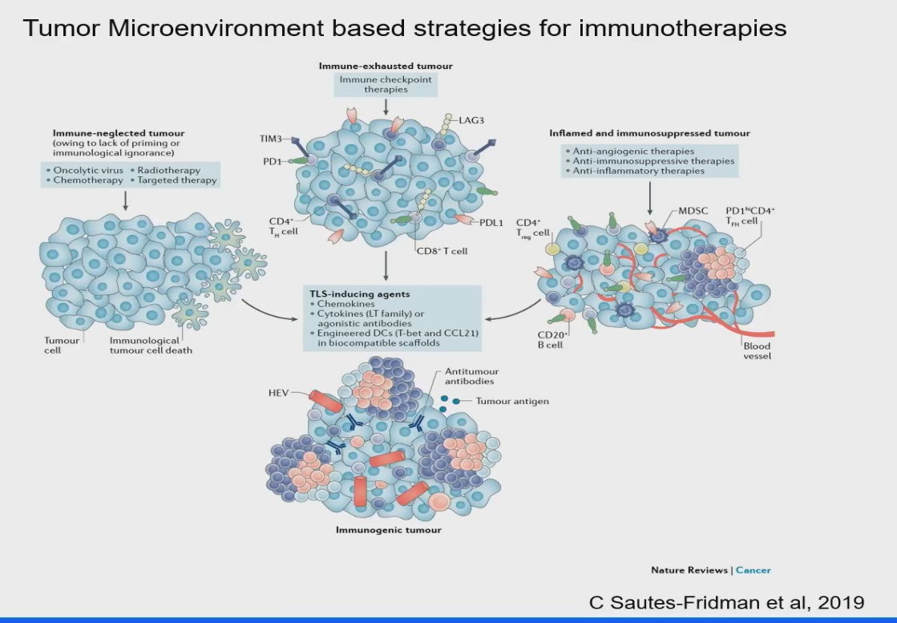

Another session on Day 1 discussed the new subcategories of NETs: update on the WHO grading and markers. This was by Massimo Millione Instituto Nazionale Tumori (Milan, Italy). The slides show the changes which have NET G1 to Ki-67 3% and amendment to NECG3 which is further demonstrated in slide 2 the prognosis of Type B & C NEC G3 >55%.
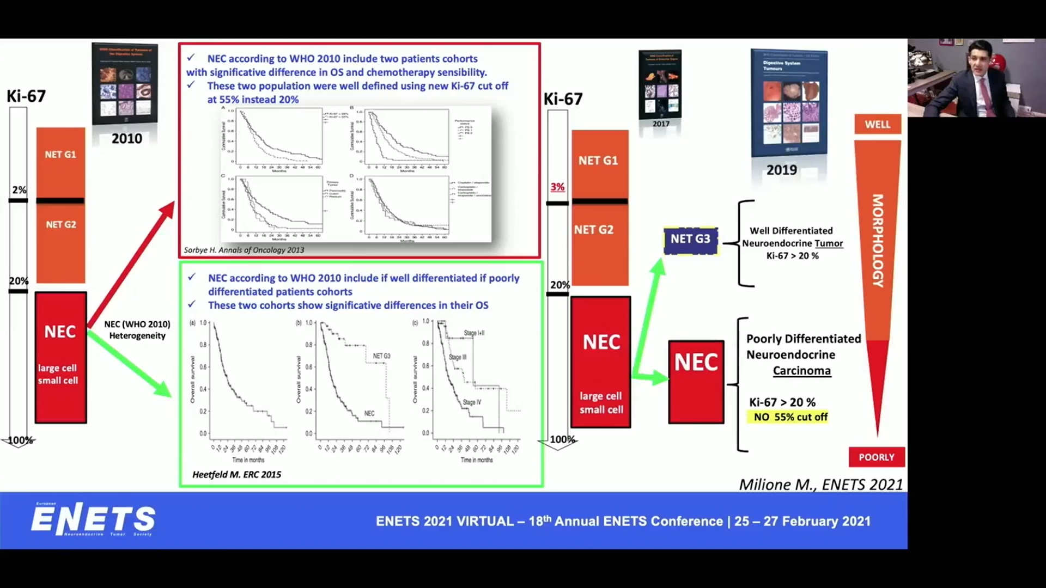

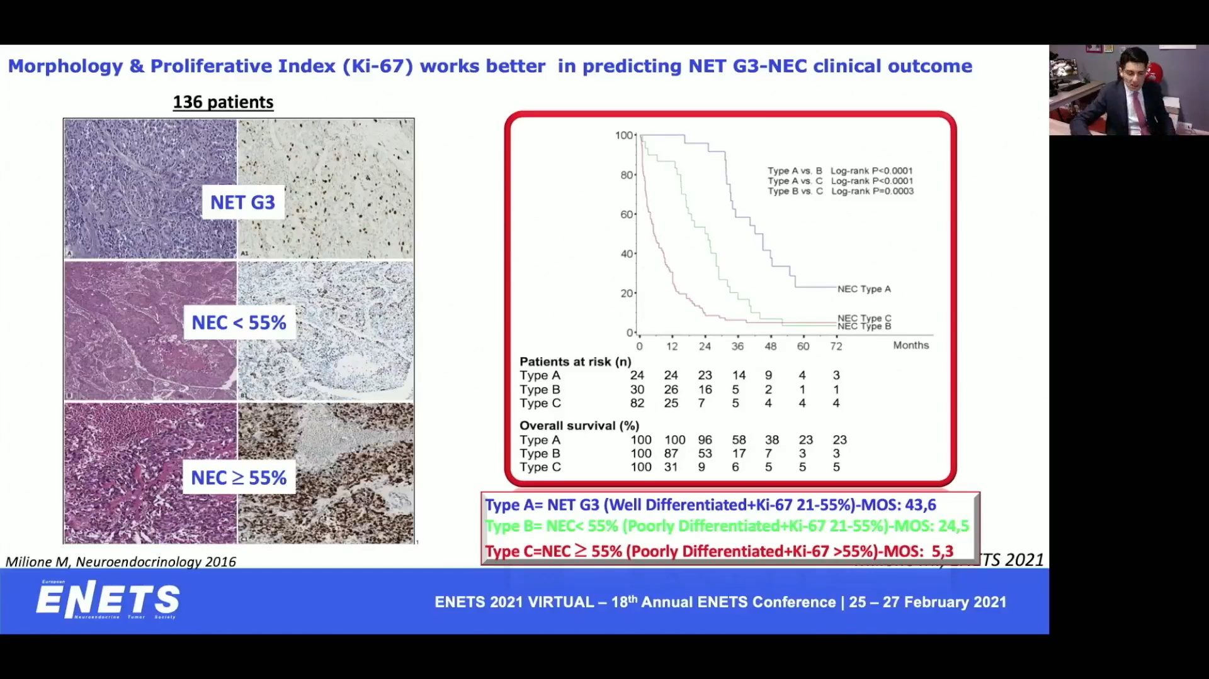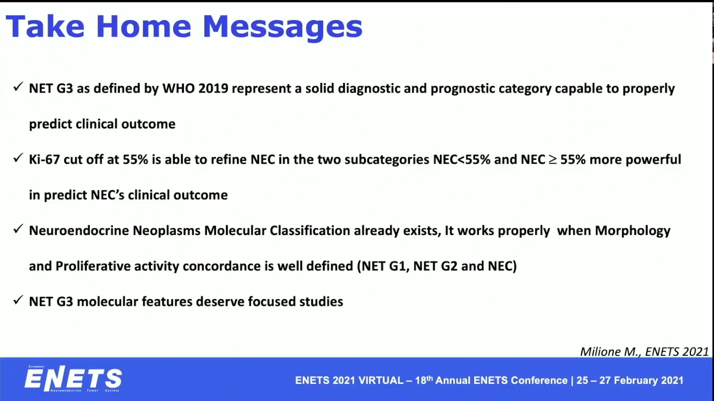

Leonidas Apostolidis from Department of Medical Oncology Heidelberg Germany provided an overview of work which has investigated the comparison between NET G3 & NEC G3. Interestingly there has been some response in NEC G3 to Immunotherapy (see below)

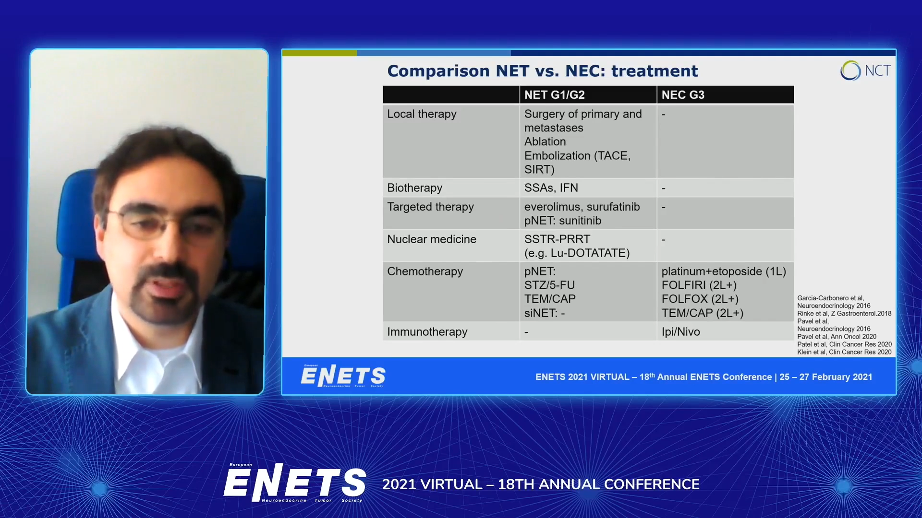

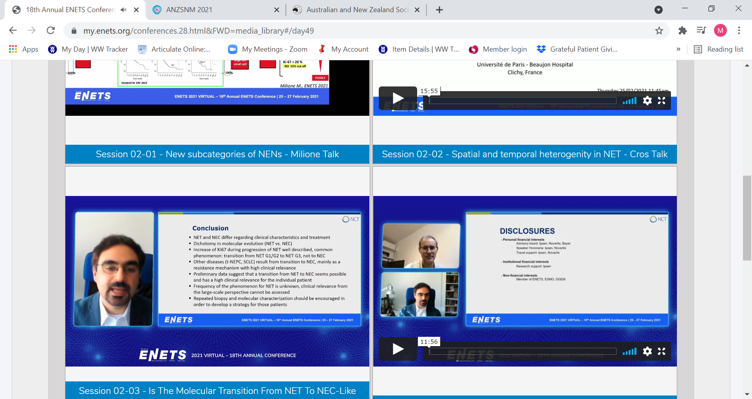

There were just under 200 abstracts accepted and available for viewing which included 2 from NeuroEndocrine Cancer Australia. We were really thrilled to have the posters accepted. They were our GP Education Course and Getting Results.
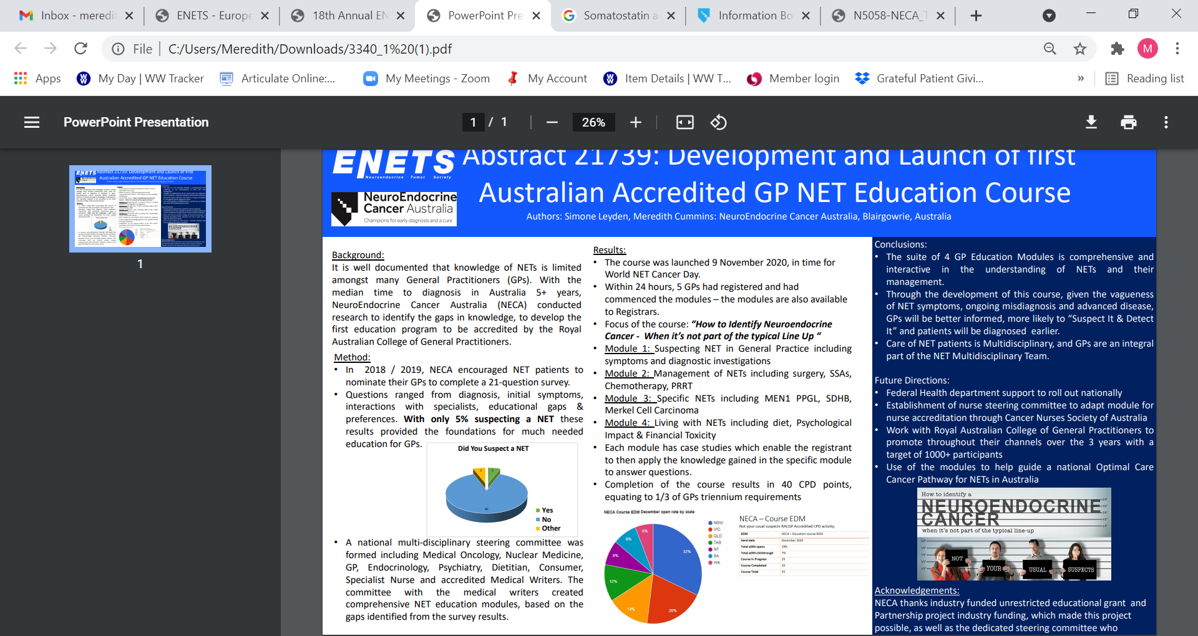

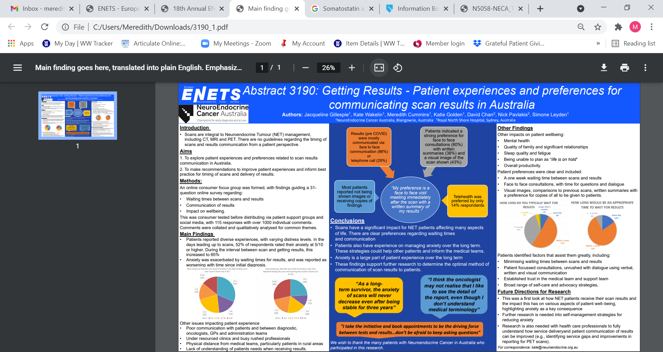

Other posters of interest were –
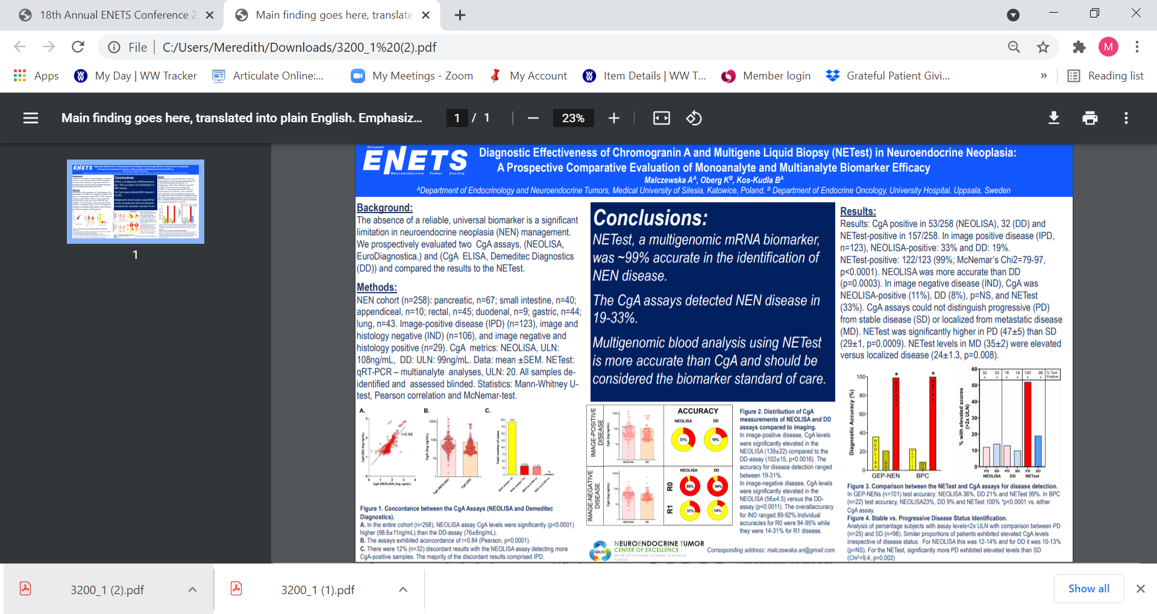
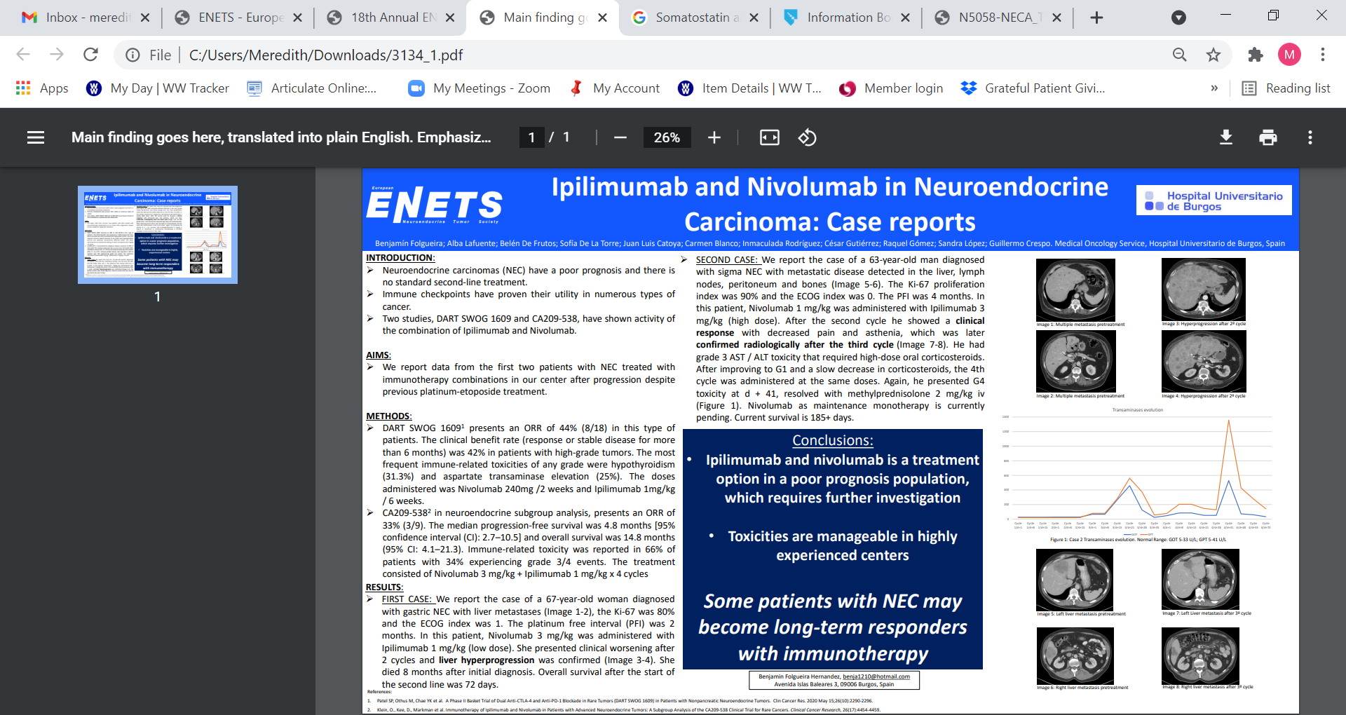
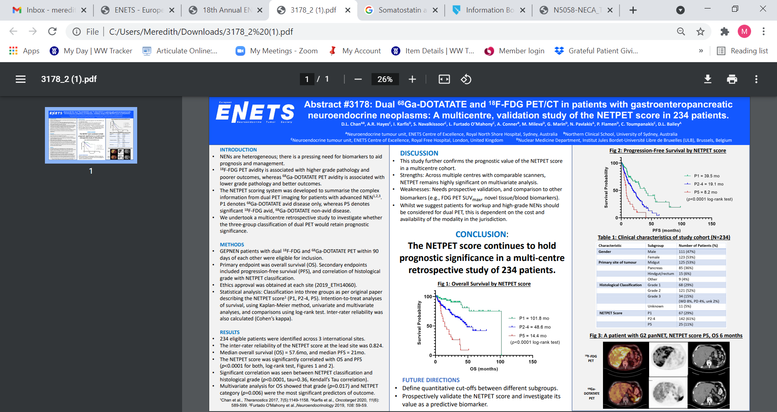

On Friday afternoon (CET) which was 2am (AEST) – the International Neuroendocrine Cancer Alliance (INCA) held a very interesting session which included -
- Early Diagnosis Challenges as reported in SCAN 7 SCAN II launch – Dr Sugandra Duneja (Nuclear Medicine Physician, India)
- Impact of misdiagnosis on healthcare systems and patients – understanding barriers to early diagnosis – the results of a survey from November 2020 were presented with a total of 880 reposes Catherine Bouvier NCUK. A summary of the recommendations of the respondents is in the slide below.

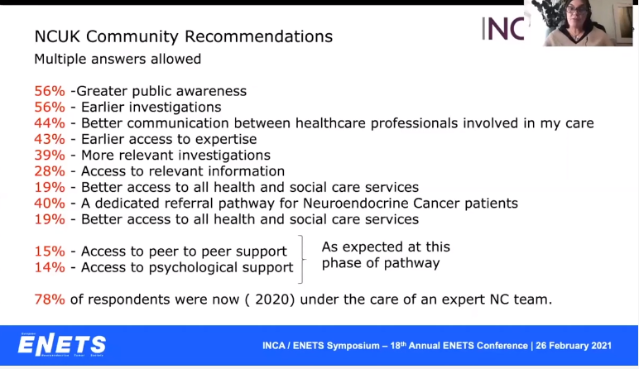

- Improving time to diagnosis – need for GP Education and Optimal Cancer care Pathway for NETs – our own Simone Leyden NeuroEndocrine Cancer Australia.
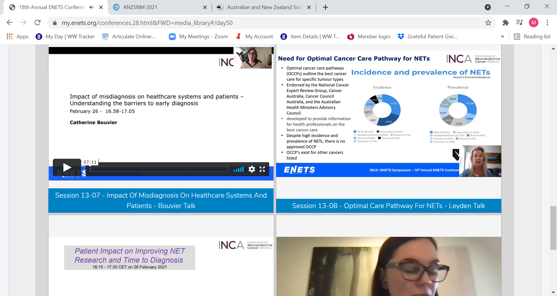

- The final session was NET misdiagnosis and late diagnosis: How can we have a positive impact on changing the facts presented by Dermot O’Toole - Gastroenterologist NET Centre of Excellence Dublin. As per the slides below the issue of awareness and education were at the forefront.
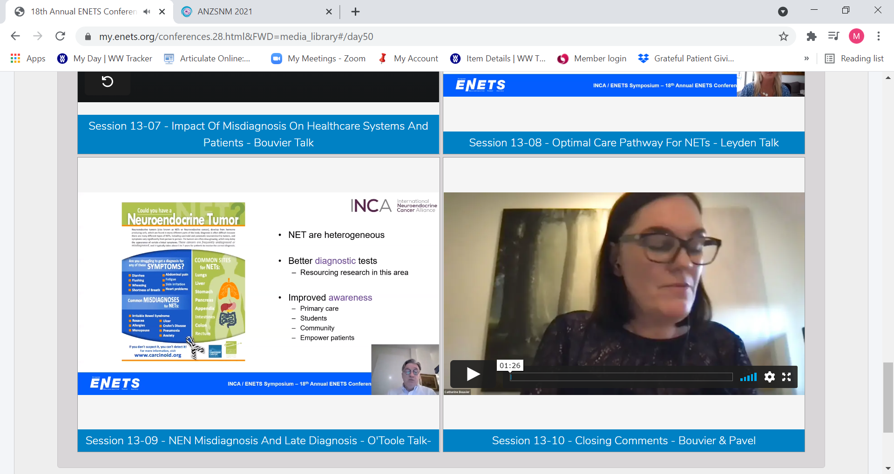
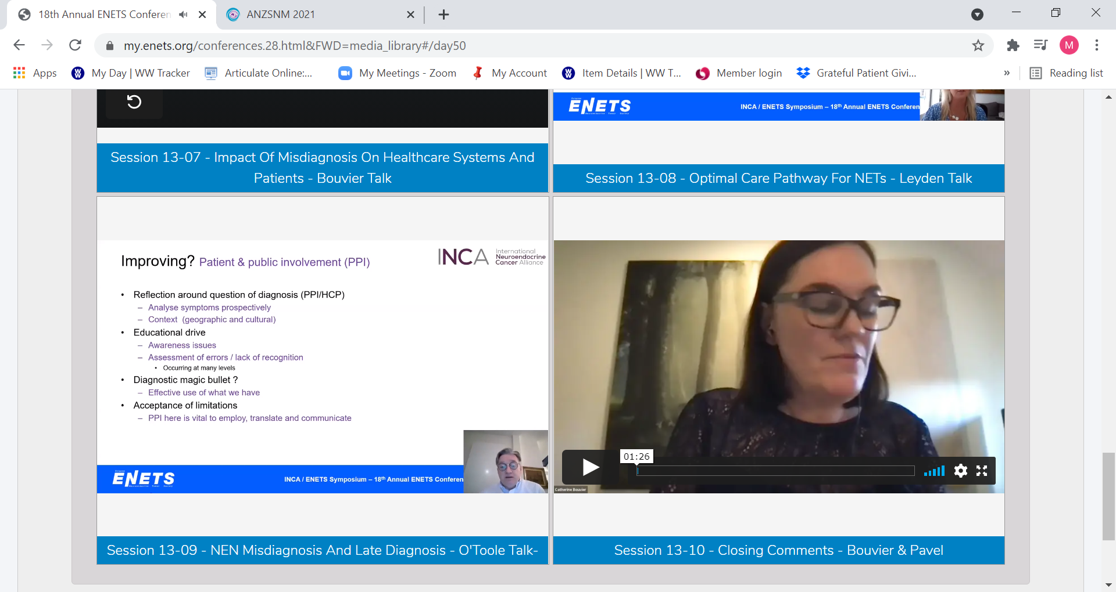
Following on from there was a general discussion about ways in which internationally the issue of misdiagnosis could be addressed. The development of the GP Education modules in Australia was highly acknowledged and also prompted the need for other disciplines to have access to this education such as gastroenterologists. This will continue to be evaluated and could develop into an international implementation of the education modules.
Report by Meredith Cummins NECA Project Officer / CRA

